TV Access Project (TAP)

ACCESS PASSPORT

[INSERT PRODUCTION  LOGO] | This document is an Access Passport.  At [NAME OF PRODUCTION / ORGANISATION], we want to support everyone to have the best possible experience when working with us.  By sharing details about your access with us, you’re helping us to support you.
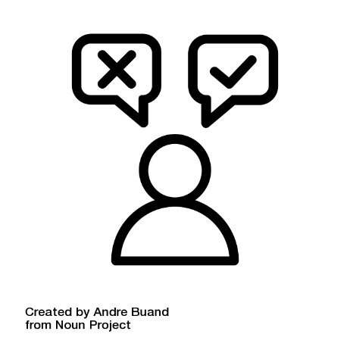 | About This Access Passport  This Access Passport is optional.  You can communicate your access requirements however works best for you.  It is up to you how much you want to share to answer each question.
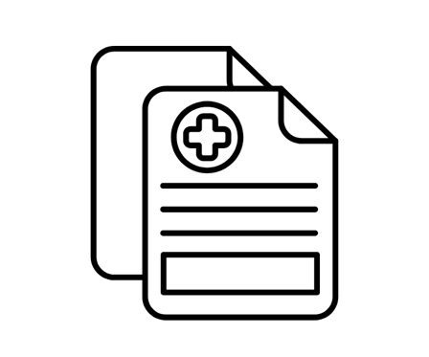 | Medical History  You do not need to share details about your medical history unless you would like to include it.
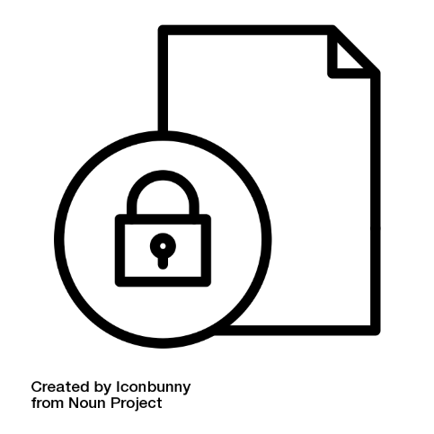 | Confidentiality  Your Access Passport is confidential.  You own this document.  This passport can be shared with your line manager or other team members to best support you.  It is up to you if you want to share your Access Passport with anyone else on the team.
 | Making changes  You can review or edit your Access Passport at any time.

Your Details

 | Your Name  Your Pronouns  Your Role
 | Your Phone Number
 | Your Email Address
 | Disability or health  Do you identify as disabled or with having a health condition?

Tell us about you

 | Tell us anything you would like us to know that might help us support you  Some examples of information that might be useful are below  You don’t have to answer every section
 | Medication  - In this box you can share information about medication you might take  - For example, does your medication impact you at work?  - Do you need to take it at a certain time of day?
 | Access requirements  - Do you have any access requirements?  - Do your access requirements change from day to day?

 | Emergencies  Do you have any information that might be useful in case of an emergency  For example, emergency medication like an EpiPen?
 | Anything else  Is there anything else we can do support you?

What adjustments do you need?

 | Let us know any adjustments you already have in place or new ones you would like to be put in place.  Some examples of adjustments you might find helpful are below.  You might want to include adjustments you only need some of the time, as your access requirements might change.
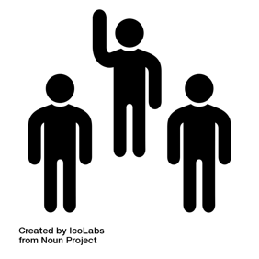 | Do you need interpreters or support workers?
 | Do you need adjustments to travel?
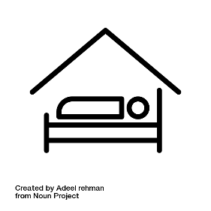 | Do you need adjustments to accommodation?
 | Quiet Space  Do you need a quiet space available?


Working Hours

Do you need adjustments to working hours?

 | Equipment or software  Do you need adjustments to equipment or software?
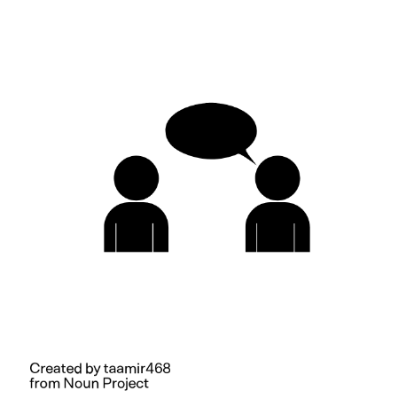 | Communication  Do you have communication preferences?
Other adjustments

Are there other adjustments you would like to put in place?

Anything Else?

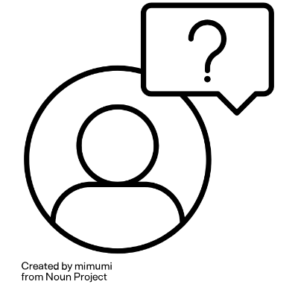 | Use this space to share any other information that might be relevant so that you can feel supported at work
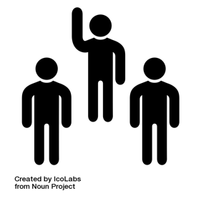 | If you would prefer that we talk about your access with someone else, please include their details here  This might be a support worker or advocate
You might not know what adjustments you might need

If you want support to think about this more, tell us here

What happens next?

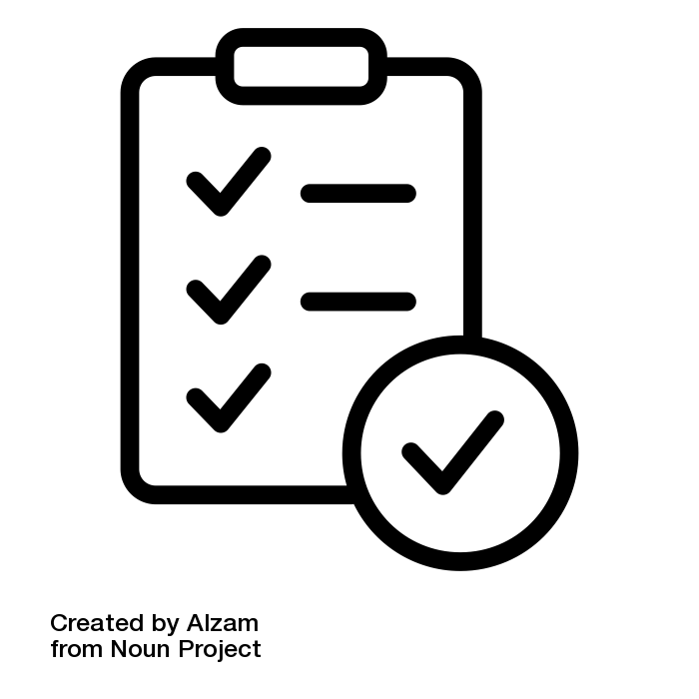 | Confirming your Access Passport  After you have completed the Access Passport, send written confirmation of your adjustments to your line manager via email
Making changes

Remember that you can review or edit your Access Passport at any time

Questions?

 | Email  [NAME OF LINE MANAGER / ACCESS LEAD]  [EMAIL]

